**A COMPREHENSIVE ANALYSIS OF FINANCIAL PERFORMANCE: INSIGHTS FROM A LEADING BANKS**

Submitted by

**K.SADHANA**

(Reg. No. 12020U25022)

**S.PRATHIPA**

(Reg. No. 12020U25019)

**R.PRIYANKA**

(Reg. No. 12020U25020)

**S.RAMYA**

(Reg. No. 12020U25021)

DEPARTMENT OF

BACHELOR OF SCIENCE IN MATHEMATICS



**KRISHNASAMY COLLEGE OF SCIENCE, ARTS & MANAGEMENT FOR WOMEN – CUDDALORE**

**PROJECT CONTENT**

1. INTRODUCTION
   1. Overview
   2. Purpose
2. PROBLEM DEFINITION & DESIGN THINKING
   1. Empathy Map
   2. Ideation & Brainstorming Map
3. RESULT
4. ADVANTAGES & DISADVANTAGES
5. APPLICATIONS
6. CONCLUSION
7. FUTURE SCOPE
8. APPENDIX
9. SQL Source Code
10. HTML Source Code

**1.INTRODUCTION**

1.1 Overview

The banking industry world-wide is being transformed. The global forces for change include technological innovation; the deregulation of financial services at the national level and opening-up to international competition; and - equally important - changes in corporate behavior, such as growing disintermediation and increased emphasis on shareholder value. In addition, recent banking crises in Asia and Latin America have accentuated these pressures. The banking industries in central Europe and Latin America have also been transformed as a result of privatizations of state-owned banks that had dominated their banking systems in the past. In this project we are trying to analysis the bank related data and able to extract some insights from the data using Business Intelligence tools. To Extract the Insights from the data and put the data in the form of visualizations, Dashboards and Story we employed Tableau tool.

1.2 Purpose

* The financial performance tells investors about the general well-being of a firm. It's a snapshot of its economic health and the job its management is doing.
* A key document in reporting corporate financial performance is Form 10-K, which all public companies are required to publish annually.
* Financial statements used in evaluating overall financial performance include the balance sheet, the income statement, and the statement of cash flows.
* Financial performance indicators are quantifiable metrics used to measure how well a company is doing.
* No single measure should be used to define the financial performance of a firm.

To assess financial statements which contain information on past performances and interpret it as a basis for forecasting future rates of return and for assessing risk. For determining credit risk, deciding the terms and conditions of a loan if sanctioned, interest rate, and maturity date etc.

**2. PROBLEM DEFINITION & DESIGN THINKING**

* 1. Empathy Map

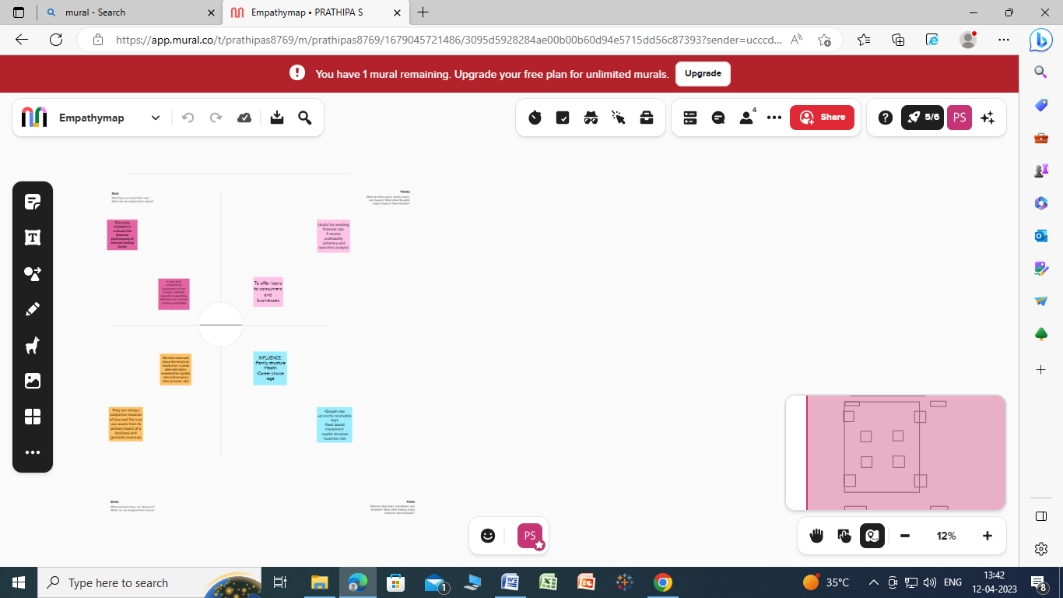

2.2 Ideation & Brainstorming Map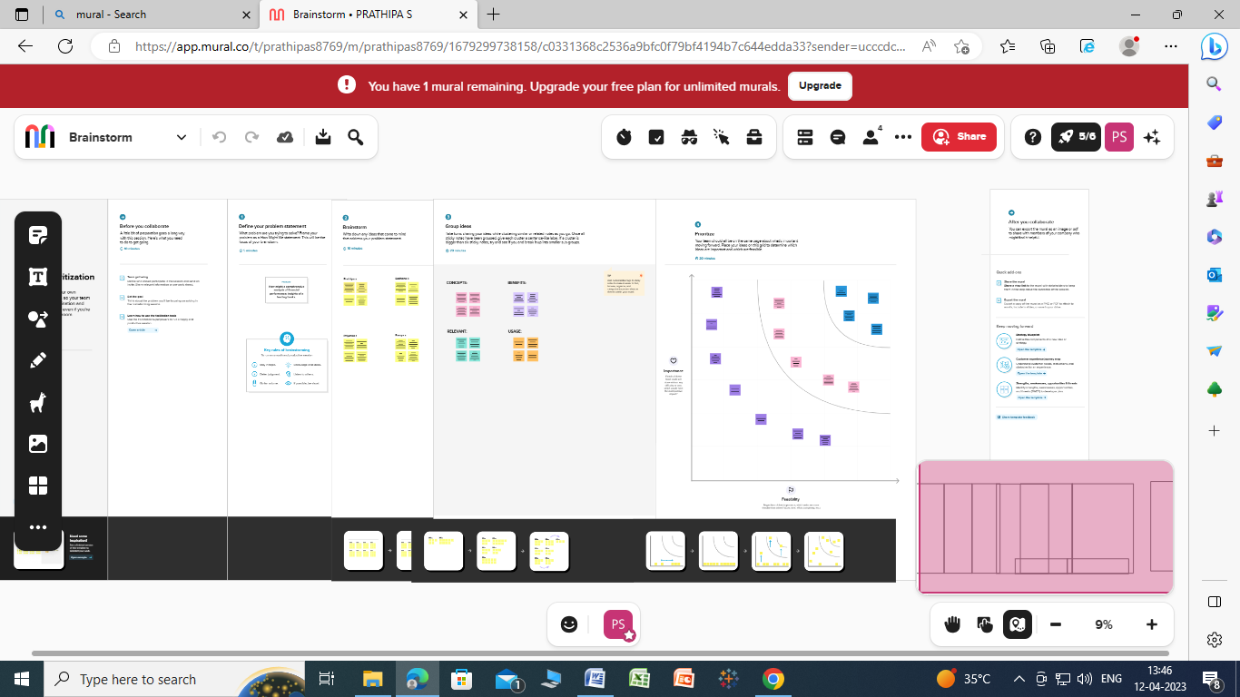

1. **RESULT**

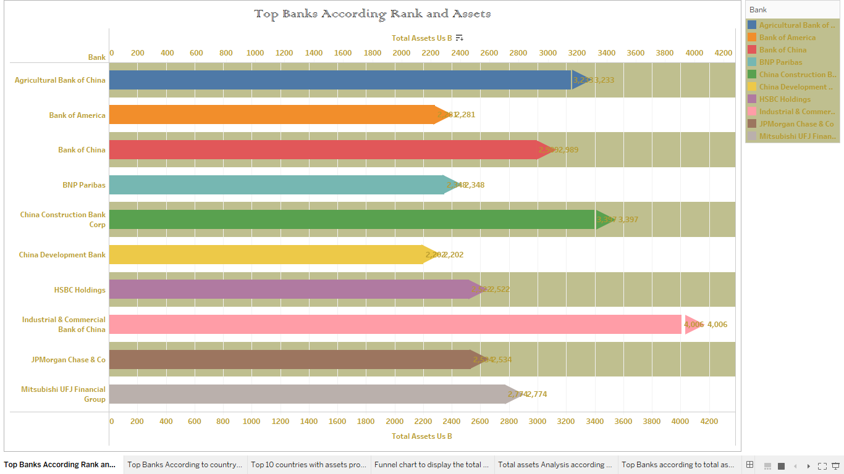

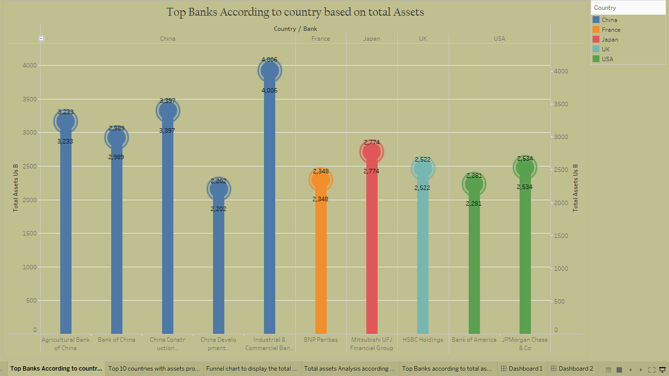

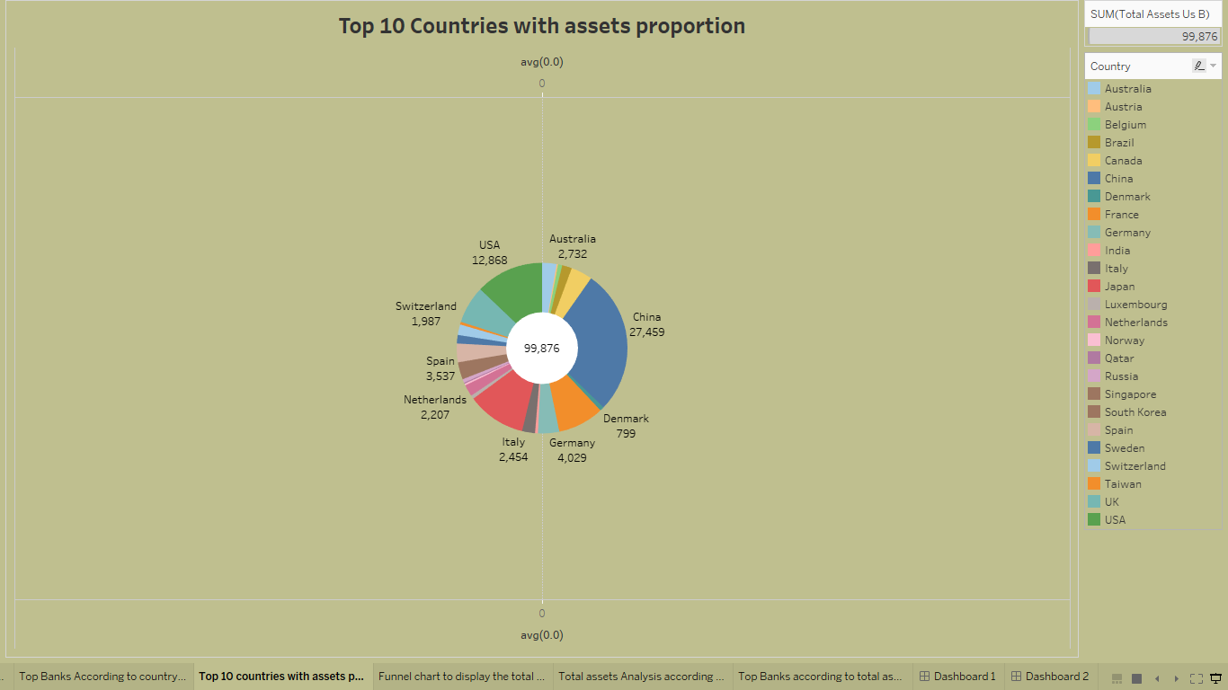

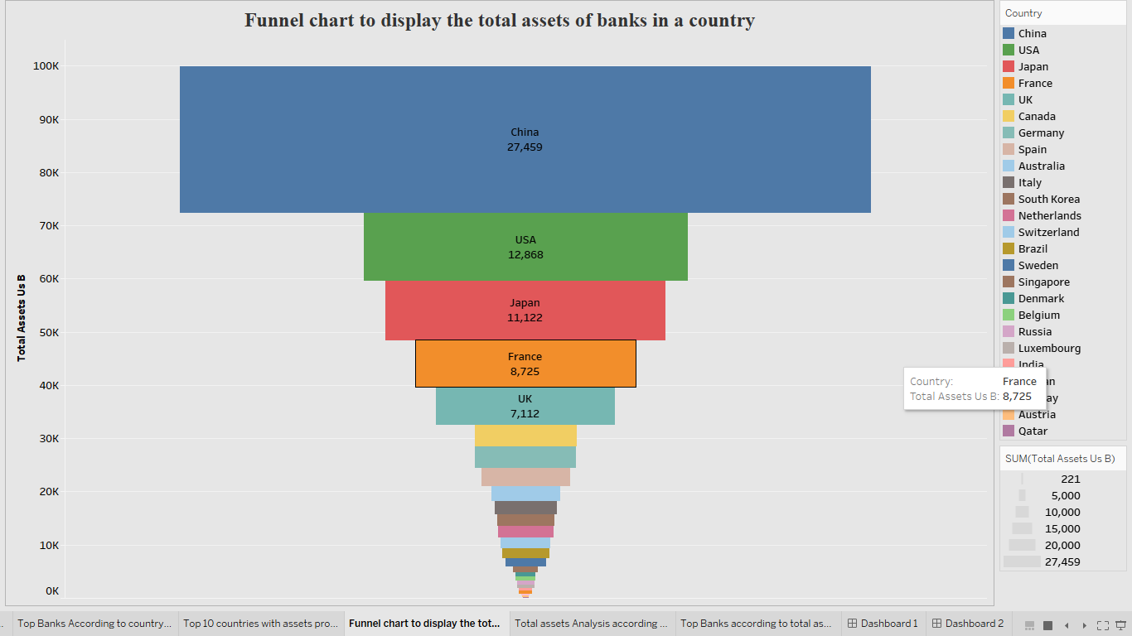

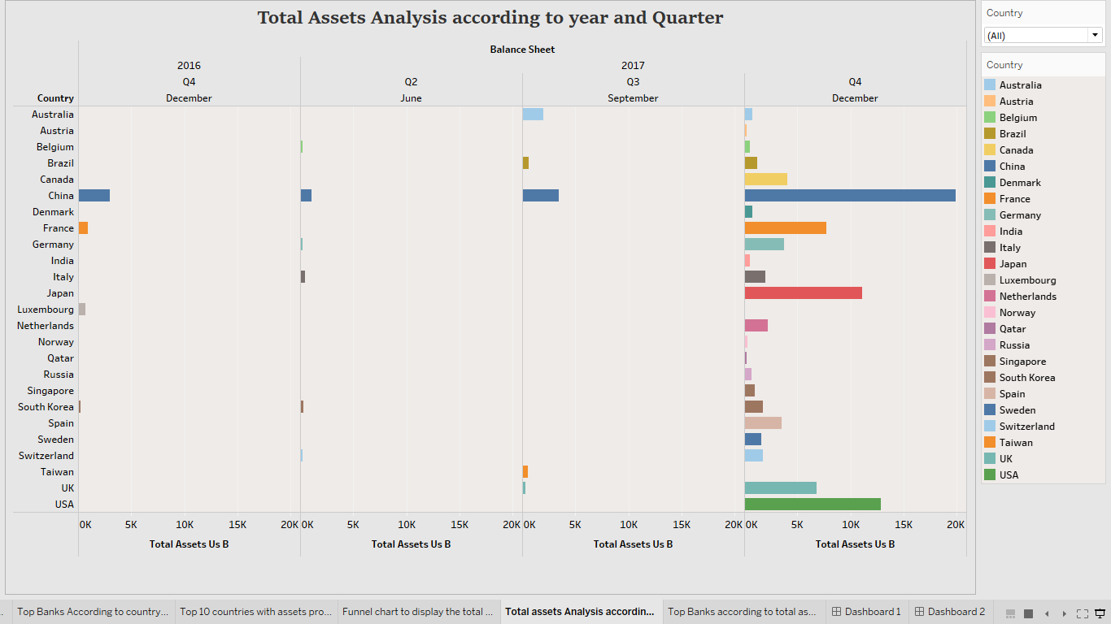

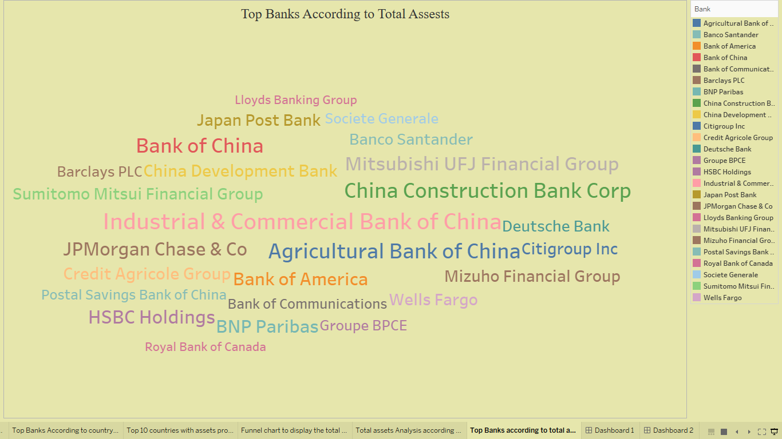

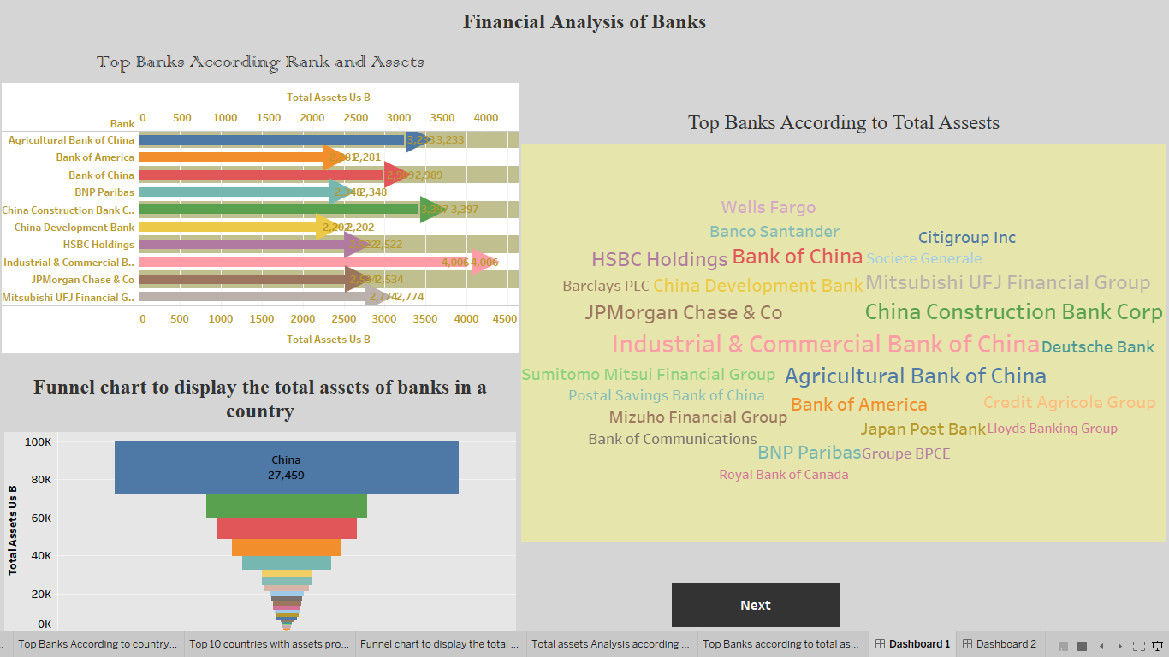

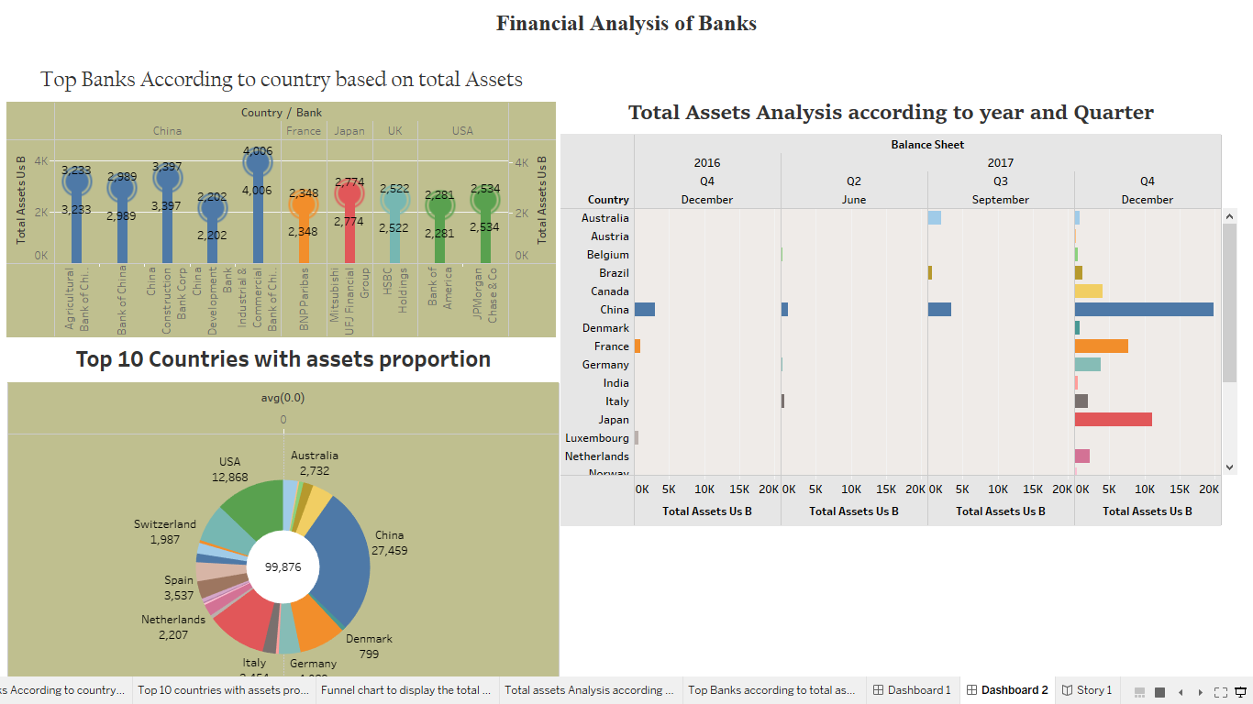

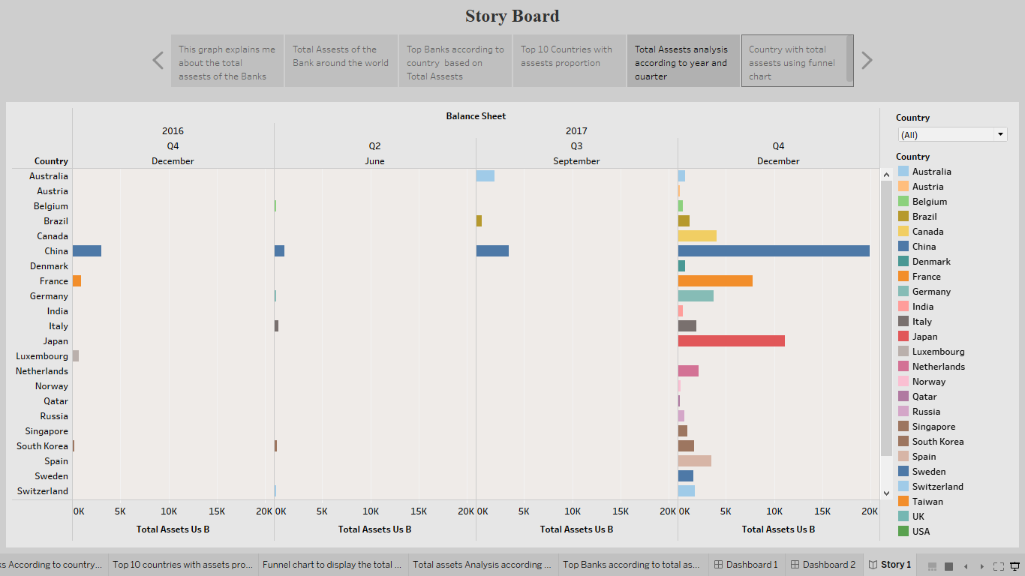

1. **ADVANTAGES & DISADVANTAGES**

**Advantages:**

## The Ability to Detect Patterns

Financial statements reveal how much a company earns per year in sales. The sales may fluctuate, but financial planners should be able to identify a pattern over years of sales figures. For example, the company may have a pattern of increased sales when a new product is released. The sales may drop after a year or so of being on the market. This is beneficial, as it shows potential and sales patterns so executives know to expect a drop in sales.

## A Chance to Budget Outline

Another advantage of using financial statements for future planning and decision making is that they show the company’s budgets. The budgets reveal how much wiggle room the company has to spend on launching products, developing marketing campaigns or expanding the current office size. Knowing how much money is available for planning and decision making ensures that the company does not spend more than expected.

**Disadvantages:**

## Based on Market Patterns

One disadvantage of using financial statements for decision making is that the data and figures are based on the market at that given time. Depending on the market, it may change quickly, so executives should not assume that the numbers from a previous financial statement will remain the same or increase. Just because a company has sold 5 million copies of a product during one year does not guarantee it will sell the same amount or more. It may sell much less if a competitor releases a similar product.

## At-One-Time Analysis

Another disadvantage is that a single financial statement only shows how a company is doing at one single time. The financial statement does not show whether the company is doing better or worse than the year before, for example. If executives decide to use financial statements for making decisions about the future, they should use several financial statements from previous months and years to ensure they get an overall picture of how much the company is doing. The financial statement becomes a continuous analysis, which is more useful than using a single statement.

1. **APPLICATIONS**

The financial analysis aims to [analyze whether an entity is stable](https://www.investopedia.com/what-is-alternative-data-6889002), liquid, solvent, or profitable enough to warrant a monetary investment. It is used to evaluate economic trends, set financial policies, build long-term plans for business activity, and identify projects or companies for investment.

Financial analysis can be conducted in both corporate finance and investment finance settings. A financial analyst will thoroughly examine a company's financial statements—the income statement, balance sheet, and cash flow statement.

One of the most common ways to analyze financial data is to calculate ratios from the data in the financial statements to compare against those of other companies or against the company's own historical performance. A key area of corporate financial analysis involves extrapolating a company's past performance, such as net earnings or profit margin, into an estimate of the company's future performance.

1. **CONCLUSION**

Analysis of financial statements is extremely important for every business to grow and increase their revenue. It should not be compromised since it increases the efficiency of business operations. Better processes and expert analysts can help in the detailed analysis process.Help organisations to take critical financial decisions. Ensure effective utilisation and allocation of resources. Help in improving return on investment of the organisation.

1. **FUTURE SCOPE**

Analytics can be used to identify and rate individual customers who are at risk of fraud and then apply different levels of monitoring and verification to those accounts. Analyzing the risk of the accounts allows banks and financial institutions to know what to prioritize in their fraud detection efforts.  Banks can realign to compete in new arenas, organized around distinct customer needs. These arenas will expand far beyond the current definition of financial services, and they will also be hotly contested by a wide range of tech giants, tech start-ups, and other nonbanks.

1. **APPENDIX**
2. SQL Source Code

create financial_performance;

use financial_performance;

select*from top_banks;

1. HTML Source Code

<DOCTYPE html>

<html lang="en">

<head>

<meta charset="utf-8">

<meta content="width=device-width, initial-scale=1.0" name="viewport">

<title>fin Analytica</title>

<meta content="" name="description">

<meta content="" name="keywords">

<!-- Favicons -->

<link href="assets/img/favicon.png" rel="icon">

<link href="assets/img/apple-touch-icon.png" rel="apple-touch-icon">

<!-- Google Fonts -->

<link rel="preconnect" href="https://fonts.googleapis.com">

<link rel="preconnect" href="https://fonts.gstatic.com" crossorigin>

<link href="https://fonts.googleapis.com/css2?family=Open+Sans:ital,wght@0,300;0,400;0,500;0,600;0,700;1,300;1,400;1,600;1,700&family=Montserrat:ital,wght@0,300;0,400;0,500;0,600;0,700;1,300;1,400;1,500;1,600;1,700&family=Raleway:ital,wght@0,300;0,400;0,500;0,600;0,700;1,300;1,400;1,500;1,600;1,700&display=swap" rel="stylesheet">

<!-- Vendor CSS Files -->

<link href="assets/vendor/bootstrap/css/bootstrap.min.css" rel="stylesheet">

<link href="assets/vendor/bootstrap-icons/bootstrap-icons.css" rel="stylesheet">

<link href="assets/vendor/aos/aos.css" rel="stylesheet">

<link href="assets/vendor/glightbox/css/glightbox.min.css" rel="stylesheet">

<link href="assets/vendor/swiper/swiper-bundle.min.css" rel="stylesheet">

<!-- Template Main CSS File -->

<link href="assets/css/main.css" rel="stylesheet">

<!-- =======================================================

* Template Name: Impact

* Updated: Mar 10 2023 with Bootstrap v5.2.3

* Template URL: https://bootstrapmade.com/impact-bootstrap-business-website-template/

* Author: BootstrapMade.com

* License: https://bootstrapmade.com/license/

======================================================== -->

</head>

<body>

<!-- ======= Header ======= -->

<section id="topbar" class="topbar d-flex align-items-center">

<div class="container d-flex justify-content-center justify-content-md-between">

<div class="contact-info d-flex align-items-center">

<i class="bi bi-envelope d-flex align-items-center"><a href="mailto:finanalytica.com">contact@example.com</a></i>

<i class="bi bi-phone d-flex align-items-center ms-4"><span>+1 99999999</span></i>

</div>

<div class="social-links d-none d-md-flex align-items-center">

<a href="#" class="twitter"><i class="bi bi-twitter"></i></a>

<a href="#" class="facebook"><i class="bi bi-facebook"></i></a>

<a href="#" class="instagram"><i class="bi bi-instagram"></i></a>

<a href="#" class="linkedin"><i class="bi bi-linkedin"></i></i></a>

</div>

</div>

</section><!-- End Top Bar -->

<header id="header" class="header d-flex align-items-center">

<div class="container-fluid container-xl d-flex align-items-center justify-content-between">

<a href="index.html" class="logo d-flex align-items-center">

<!-- Uncomment the line below if you also wish to use an image logo -->

<!-- <img src="assets/img/logo.png" alt=""> -->

<h1>Fin Analytica<span>.</span></h1>

</a>

<nav id="navbar" class="navbar">

<ul>

<li><a href="#hero">Home</a></li>

<li><a href="#about">About</a></li>

<li><a href="#services">Dashboard</a></li>

<li><a href="#portfolio">Story</a></li>

<li><a href="#contact">Contact</a></li>

</ul>

</nav><!-- .navbar -->

<i class="mobile-nav-toggle mobile-nav-show bi bi-list"></i>

<i class="mobile-nav-toggle mobile-nav-hide d-none bi bi-x"></i>

</div>

</header><!-- End Header -->

<!-- End Header -->

<!-- ======= Hero Section ======= -->

<section id="hero" class="hero">

<div class="container position-relative">

<div class="row gy-5" data-aos="fade-in">

<div class="col-lg-6 order-2 order-lg-1 d-flex flex-column justify-content-center text-center text-lg-start">

<h2>Welcome to Fin <span>Analytica</span></h2>

<p>A widely used approach to analyzing a bank. CAMELS. considers a bank's capital adequeacy, asset quality. Management capabilities earnings sufficiency, liquidity position and sensitivity to market risk.</p>

<div class="d-flex justify-content-center justify-content-lg-start">

<a href="#about" class="btn-get-started">Get Started</a>

<a href="https://www.youtube.com/watch?v=LXb3EKWsInQ" class="glightbox btn-watch-video d-flex align-items-center"><i class="bi bi-play-circle"></i><span>Watch Video</span></a>

</div>

</div>

<div class="col-lg-6 order-1 order-lg-2">

<img src="assets/img/hero-img.svg" class="img-fluid" alt="" data-aos="zoom-out" data-aos-delay="100">

</div>

</div>

</div>

<div class="icon-boxes position-relative">

<div class="container position-relative">

<div class="row gy-4 mt-5">

<div class="col-xl-3 col-md-6" data-aos="fade-up" data-aos-delay="100">

<div class="icon-box">

<div class="icon"><i class="bi bi-easel"></i></div>

<h4 class="title"><a href="" class="stretched-link">statiscal analysis</a></h4>

</div>

</div><!--End Icon Box -->

<div class="col-xl-3 col-md-6" data-aos="fade-up" data-aos-delay="200">

<div class="icon-box">

<div class="icon"><i class="bi bi-gem"></i></div>

<h4 class="title"><a href="" class="stretched-link">data visualization</a></h4>

</div>

</div><!--End Icon Box -->

<div class="col-xl-3 col-md-6" data-aos="fade-up" data-aos-delay="300">

<div class="icon-box">

<div class="icon"><i class="bi bi-geo-alt"></i></div>

<h4 class="title"><a href="" class="stretched-link">Machine learning</a></h4>

</div>

</div><!--End Icon Box -->

<div class="col-xl-3 col-md-6" data-aos="fade-up" data-aos-delay="500">

<div class="icon-box">

<div class="icon"><i class="bi bi-command"></i></div>

<h4 class="title"><a href="" class="stretched-link">Artificial intelligence</a></h4>

</div>

</div><!--End Icon Box -->

</div>

</div>

</div>

</div>

</section>

<!-- End Hero Section -->

<main id="main">

<!-- ======= About Us Section ======= -->

<section id="about" class="about">

<div class="container" data-aos="fade-up">

<div class="section-header">

<h2>About Us</h2>

<p> We provide best business intelligence solutions to the companies which makes a strategy for elevating their business in the market</p>

</div>

<div class="row gy-4">

<div class="col-lg-6">

<h3>Insight generations through sophasticated tools </h3>

<img src="assets/img/about.jpg" class="img-fluid rounded-4 mb-4" alt="">

</div>

<div class="col-lg-6">

<div class="content ps-0 ps-lg-5">

<p class="fst-italic">

We provide business solutions in various domains.

</p>

<ul>

<li><i class="bi bi-check-circle-fill"></i>Insights generations using business intelligence.</li>

<li><i class="bi bi-check-circle-fill"></i>Building date models using statistics.</li>

<li><i class="bi bi-check-circle-fill"></i>Developing the predictive models.</li>

</ul>

<div class="position-relative mt-4">

<img src="assets/img/about-2.jpg" class="img-fluid rounded-4" alt="">

<a href="https://www.youtube.com/watch?v=LXb3EKWsInQ" class="glightbox play-btn"></a>

</div>

</div>

</div>

</div>

</div>

</section><!-- End About Us Section -->

<!-- ======= Stats Counter Section ======= -->

<section id="stats-counter" class="stats-counter">

<div class="container" data-aos="fade-up">

<div class="row gy-4 align-items-center">

<div class="col-lg-6">

<img src="assets/img/stats-img.svg" alt="" class="img-fluid">

</div>

<div class="col-lg-6">

<div class="stats-item d-flex align-items-center">

<span data-purecounter-start="0" data-purecounter-end="1000000" data-purecounter-duration="1" class="purecounter"></span>

<p><strong>students</strong> has succesfully trained</p>

</div><!-- End Stats Item -->

<div class="stats-item d-flex align-items-center">

<span data-purecounter-start="0" data-purecounter-end="300" data-purecounter-duration="1" class="purecounter"></span>

<p><strong>Projects</strong> has been developed</p>

</div><!-- End Stats Item -->

<div class="stats-item d-flex align-items-center">

<span data-purecounter-start="0" data-purecounter-end="10000" data-purecounter-duration="1" class="purecounter"></span>

<p><strong>Hours Of Support</strong> has been delivered</p>

</div><!-- End Stats Item -->

</div>

</div>

</div>

</section><!-- End Stats Counter Section -->

<div class="text-center"><h1>Dashboard</h1></div>

<div class='tableauPlaceholder' id='viz1681274194766' style='position: relative'><noscript><a href='#'><img alt='Financial Analysis of Banks  ' src='https:&#47;&#47;public.tableau.com&#47;static&#47;images&#47;to&#47;top_bank_&#47;Dashboard1&#47;1_rss.png' style='border: none' /></a></noscript><object class='tableauViz'  style='display:none;'><param name='host_url' value='https%3A%2F%2Fpublic.tableau.com%2F' /> <param name='embed_code_version' value='3' /> <param name='site_root' value='' /><param name='name' value='top_bank_&#47;Dashboard1' /><param name='tabs' value='no' /><param name='toolbar' value='yes' /><param name='static_image' value='https:&#47;&#47;public.tableau.com&#47;static&#47;images&#47;to&#47;top_bank_&#47;Dashboard1&#47;1.png' /> <param name='animate_transition' value='yes' /><param name='display_static_image' value='yes' /><param name='display_spinner' value='yes' /><param name='display_overlay' value='yes' /><param name='display_count' value='yes' /><param name='language' value='en-US' /><param name='filter' value='publish=yes' /></object></div>                <script type='text/javascript'>                    var divElement = document.getElementById('viz1681274194766');                    var vizElement = divElement.getElementsByTagName('object')[0];                    if ( divElement.offsetWidth > 800 ) { vizElement.style.width='100%';vizElement.style.height=(divElement.offsetWidth*0.75)+'px';} else if ( divElement.offsetWidth > 500 ) { vizElement.style.width='100%';vizElement.style.height=(divElement.offsetWidth*0.75)+'px';} else { vizElement.style.width='100%';vizElement.style.height='1027px';}                     var scriptElement = document.createElement('script');                    scriptElement.src = 'https://public.tableau.com/javascripts/api/viz_v1.js';                    vizElement.parentNode.insertBefore(scriptElement, vizElement);                </script>

<div class="text-center"><h1>Story</h1></div>

<div class='tableauPlaceholder' id='viz1681274328098' style='position: relative'><noscript><a href='#'><img alt=' ' src='https:&#47;&#47;public.tableau.com&#47;static&#47;images&#47;to&#47;top_bank_&#47;Story1&#47;1_rss.png' style='border: none' /></a></noscript><object class='tableauViz'  style='display:none;'><param name='host_url' value='https%3A%2F%2Fpublic.tableau.com%2F' /> <param name='embed_code_version' value='3' /> <param name='site_root' value='' /><param name='name' value='top_bank_&#47;Story1' /><param name='tabs' value='yes' /><param name='toolbar' value='yes' /><param name='static_image' value='https:&#47;&#47;public.tableau.com&#47;static&#47;images&#47;to&#47;top_bank_&#47;Story1&#47;1.png' /> <param name='animate_transition' value='yes' /><param name='display_static_image' value='yes' /><param name='display_spinner' value='yes' /><param name='display_overlay' value='yes' /><param name='display_count' value='yes' /><param name='language' value='en-US' /><param name='filter' value='publish=yes' /></object></div>                <script type='text/javascript'>                    var divElement = document.getElementById('viz1681274328098');                    var vizElement = divElement.getElementsByTagName('object')[0];                    vizElement.style.width='100%';vizElement.style.height=(divElement.offsetWidth*0.75)+'px';                    var scriptElement = document.createElement('script');                    scriptElement.src = 'https://public.tableau.com/javascripts/api/viz_v1.js';                    vizElement.parentNode.insertBefore(scriptElement, vizElement);                </script>

<!-- ======= Contact Section ======= -->

<section id="contact" class="contact">

<div class="container" data-aos="fade-up">

<div class="section-header">

<h2>Contact</h2>

<p> </p>

</div>

<div class="row gx-lg-0 gy-4">

<div class="col-lg-4">

<div class="info-container d-flex flex-column align-items-center justify-content-center">

<div class="info-item d-flex">

<i class="bi bi-geo-alt flex-shrink-0"></i>

<div>

<h4>Location:</h4>

<p>A108 Adam Street, New York, NY 535022</p>

</div>

</div><!-- End Info Item -->

<div class="info-item d-flex">

<i class="bi bi-envelope flex-shrink-0"></i>

<div>

<h4>Email:</h4>

<p>info@example.com</p>

</div>

</div><!-- End Info Item -->

<div class="info-item d-flex">

<i class="bi bi-phone flex-shrink-0"></i>

<div>

<h4>Call:</h4>

<p>+1 5589 55488 55</p>

</div>

</div><!-- End Info Item -->

<div class="info-item d-flex">

<i class="bi bi-clock flex-shrink-0"></i>

<div>

<h4>Open Hours:</h4>

<p>Mon-Sat: 11AM - 23PM</p>

</div>

</div><!-- End Info Item -->

</div>

</div>

<div class="col-lg-8">

<form action="forms/contact.php" method="post" role="form" class="php-email-form">

<div class="row">

<div class="col-md-6 form-group">

<input type="text" name="name" class="form-control" id="name" placeholder="Your Name" required>

</div>

<div class="col-md-6 form-group mt-3 mt-md-0">

<input type="email" class="form-control" name="email" id="email" placeholder="Your Email" required>

</div>

</div>

<div class="form-group mt-3">

<input type="text" class="form-control" name="subject" id="subject" placeholder="Subject" required>

</div>

<div class="form-group mt-3">

<textarea class="form-control" name="message" rows="7" placeholder="Message" required></textarea>

</div>

<div class="my-3">

<div class="loading">Loading</div>

<div class="error-message"></div>

<div class="sent-message">Your message has been sent. Thank you!</div>

</div>

<div class="text-center"><button type="submit">Send Message</button></div>

</form>

</div><!-- End Contact Form -->

</div>

</div>

</section><!-- End Contact Section -->

</main><!-- End #main -->

<!-- ======= Footer ======= -->

<footer id="footer" class="footer">

<div class="container">

<div class="row gy-4">

<div class="col-lg-5 col-md-12 footer-info">

<a href="index.html" class="logo d-flex align-items-center">

<span>Fin Analytica</span>

</a>

<p>We provide solutions to your business</p>

<div class="social-links d-flex mt-4">

<a href="#" class="twitter"><i class="bi bi-twitter"></i></a>

<a href="#" class="facebook"><i class="bi bi-facebook"></i></a>

<a href="#" class="instagram"><i class="bi bi-instagram"></i></a>

<a href="#" class="linkedin"><i class="bi bi-linkedin"></i></a>

</div>

</div>

<div class="col-lg-2 col-6 footer-links">

<h4>Useful Links</h4>

<ul>

<li><a href="#">Home</a></li>

<li><a href="#">About us</a></li>

<li><a href="#">Services</a></li>

<li><a href="#">Terms of service</a></li>

<li><a href="#">Privacy policy</a></li>

</ul>

</div>

<div class="col-lg-2 col-6 footer-links">

<h4>Our Services</h4>

<ul>

<li><a href="#">Web Design</a></li>

<li><a href="#">Web Development</a></li>

<li><a href="#">Product Management</a></li>

<li><a href="#">Marketing</a></li>

<li><a href="#">Graphic Design</a></li>

</ul>

</div>

<div class="col-lg-3 col-md-12 footer-contact text-center text-md-start">

<h4>Contact Us</h4>

<p>

A108 Adam Street <br>

New York, NY 535022<br>

United States <br><br>

<strong>Phone:</strong> +1 5589 55488 55<br>

<strong>Email:</strong> info@example.com<br>

</p>

</div>

</div>

</div>

</footer><!-- End Footer -->

<!-- End Footer -->

<a href="#" class="scroll-top d-flex align-items-center justify-content-center"><i class="bi bi-arrow-up-short"></i></a>

<div id="preloader"></div>

<!-- Vendor JS Files -->

<script src="assets/vendor/bootstrap/js/bootstrap.bundle.min.js"></script>

<script src="assets/vendor/aos/aos.js"></script>

<script src="assets/vendor/glightbox/js/glightbox.min.js"></script>

<script src="assets/vendor/purecounter/purecounter_vanilla.js"></script>

<script src="assets/vendor/swiper/swiper-bundle.min.js"></script>

<script src="assets/vendor/isotope-layout/isotope.pkgd.min.js"></script>

<script src="assets/vendor/php-email-form/validate.js"></script>

<!-- Template Main JS File -->

<script src="assets/js/main.js"></script>

</body>

</html>